Steps to run and test

Pull the repository from :

[GitHub - CryptoBuild/Santander](https://github.com/CryptoBuild/Santander)

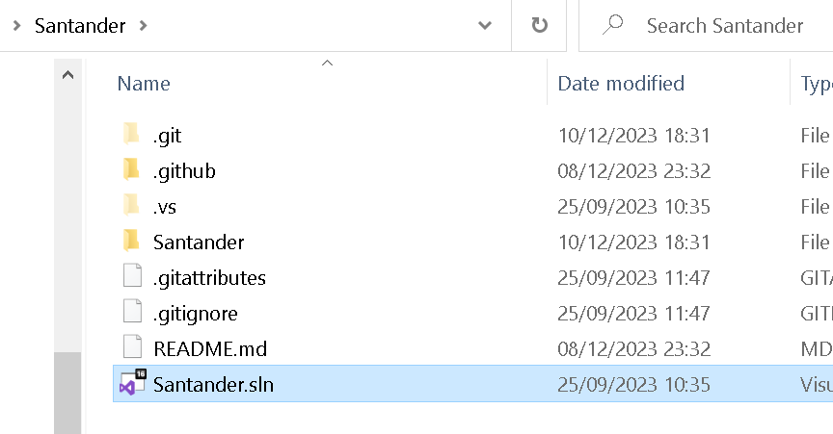

Open the solution

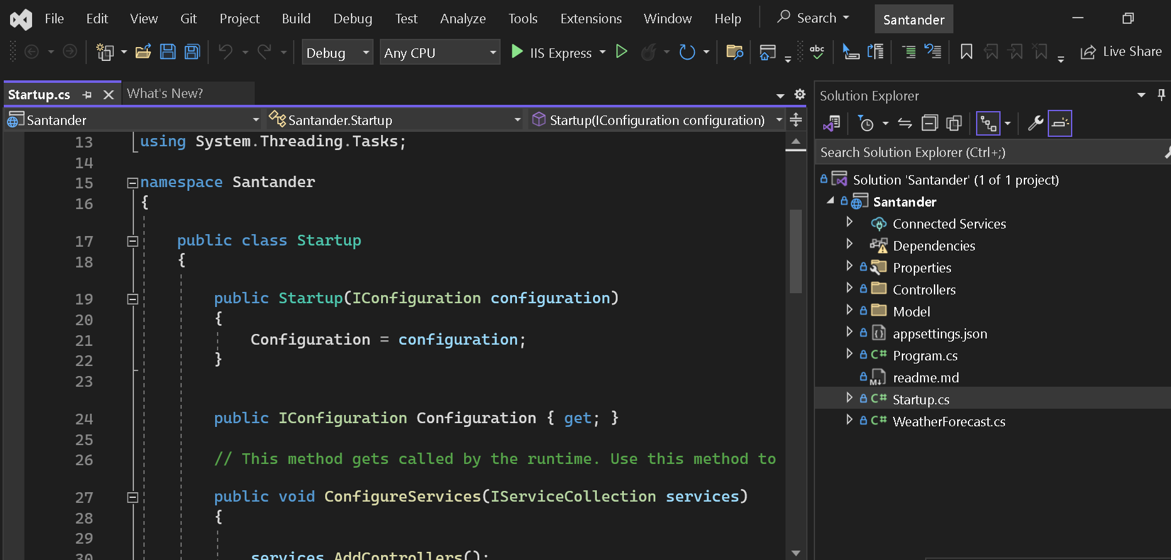

Then execute the solution with IIS Express for now. Deployment to IIS would be the host eventually for proper deployment.

Running the solution launches a browser and as this app has swagger built into it the following test framework is displayed:

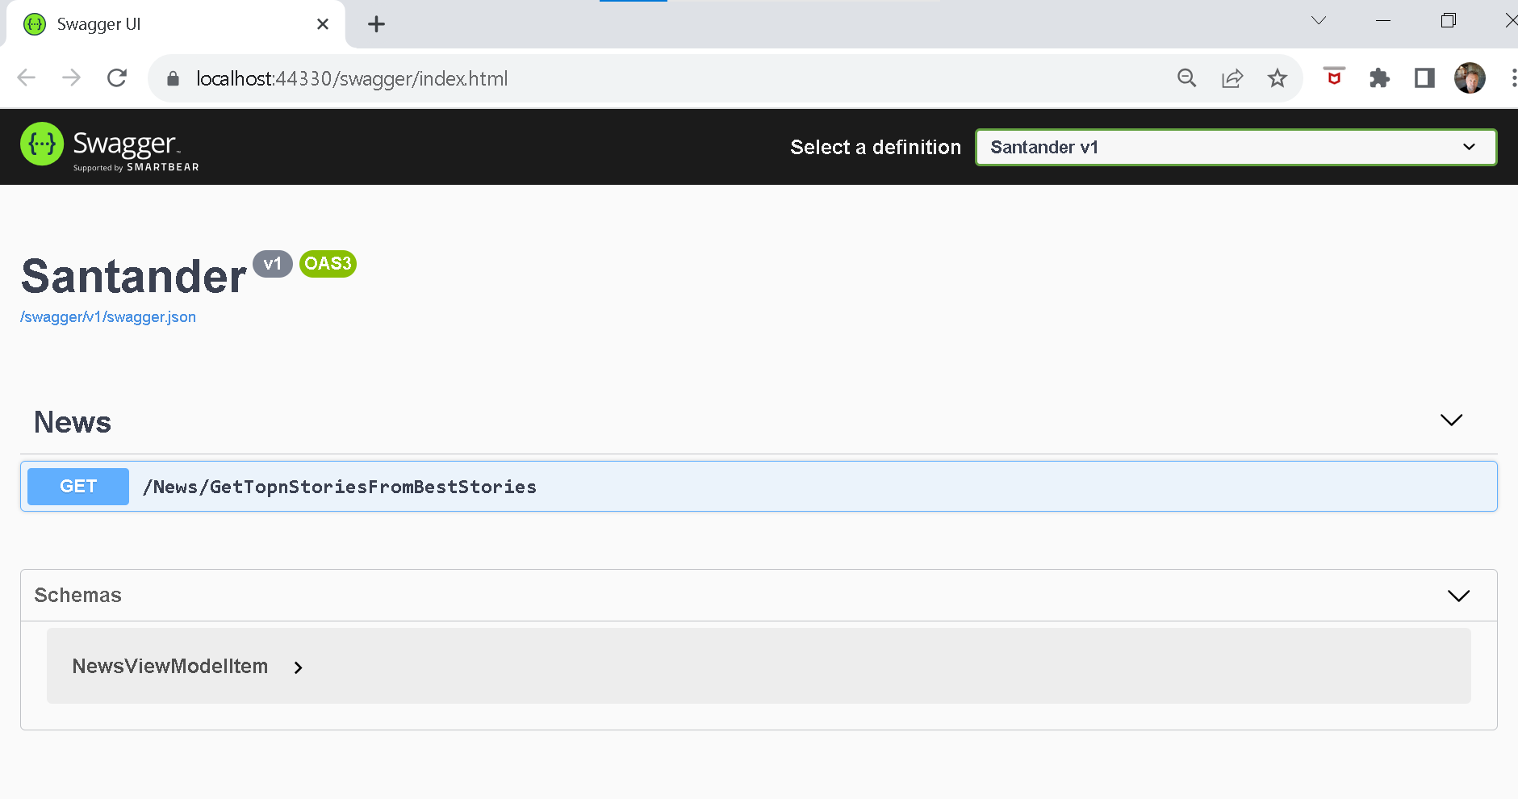Select GET :

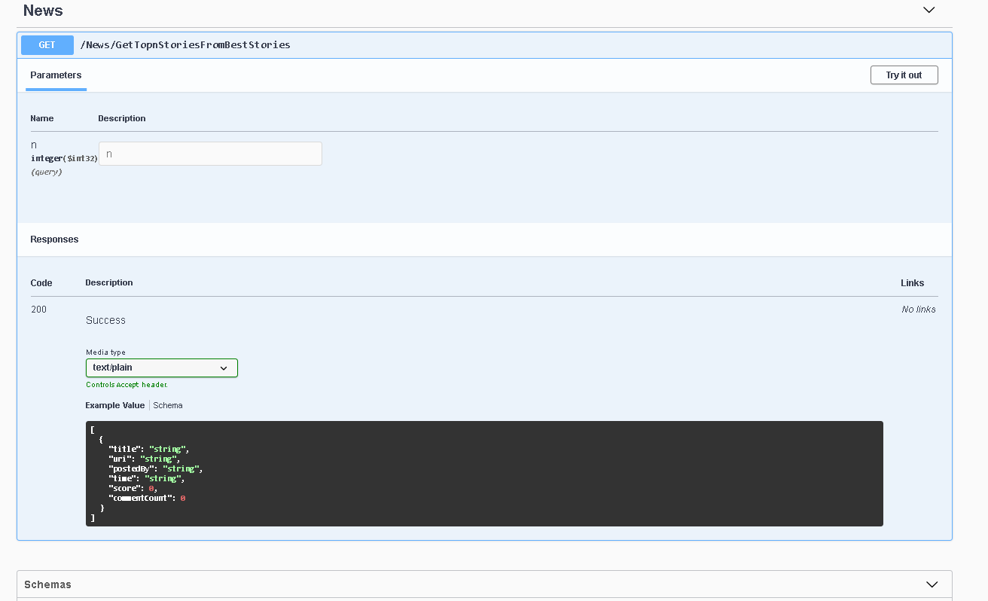

This displays the new api details.

Next select try it out.

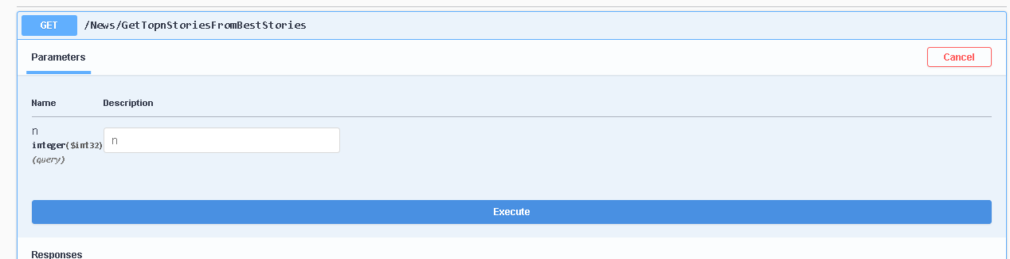This allows you to plug in a value into the call to return the number of top story details from the best stories call.

The first time this runs the best stories will all be brought done to the client as below:

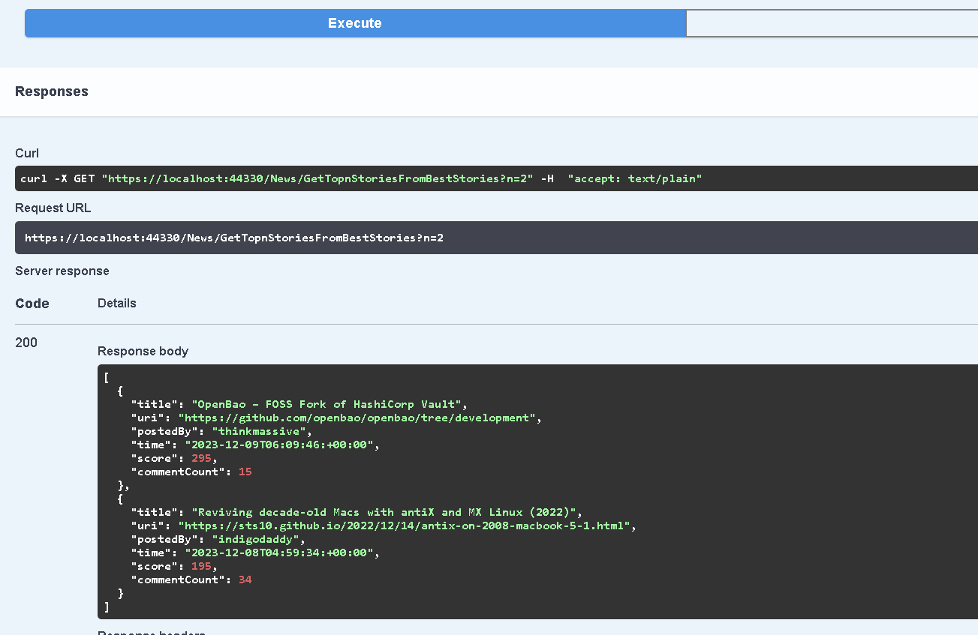

The initial call to get the best stories is done in parallel to ensure performant response and subsequent calls simple use the cached version of the cached view model.

Amending the number in the api call and re-selecting execute will bring back the new number of items as below from a cached version of the stored records.

This runs very fast as the call to the new service is not needed.